Reading Response Option 16

The excerpted reading arrives from John Berger’s book, Ways of Seeing, which traces out various histories of art creation and spectatorship. In the selected chapter, Berger deals specifically with gender. How does Berger interpret the differences between male and female bodies appearing in art? How do these conventions relate to how gender is understood by society? Berger’s text was written in 1972. Do you think that Berger’s ideas are still applicable to today’s society?

Finally, Berger concludes his chapter by asking the viewer to imagine swapping the body of a woman with the body of a man in any of the classical nudes used in his discussion. Luckily for us, the Japanese photographer, Yasumasa Morimura, who focuses on identity issues in his artistic practice, has answered Berger’s request. In the work below, Portrait (Futago), Morimura poses as both Olympia (from Manet’s painting) and her maid. Does this gesture change your experience of the work? How?
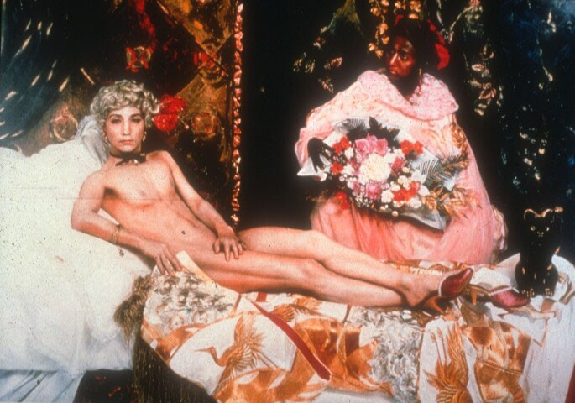

Yasumasa Morimura, Portrait (Futago), 1988

